Request: daily SKU Storage by location

ASR 7035

Proposed:

## Updated Changes from Customer:

**From:** Tan, Wee Jian   
**Sent:** Wednesday, 04 April, 2018 2:25 PM  
**To:** Chan, Pei-Fong  
**Subject:** RE: RDC storage monitoring dashboard

Hi Pei Fong,

The bin location-day report is very close to what I’m looking for. I’d just like to clarify a few things:

1.       How is the report date range defined? Is it by in date, out date or last snap date?

(This is what I’d like to see:

if I define date range as 1 to 31 Mar, the report should only show SKUs that were present during March.

If 5 pallets of SKU 123 arrived on 15 Feb, and left on 10 Mar, they should only be recorded as (5 pallets x 10 days = 50) location-days in the March report.)

            PF: we can re-design the report logic to present the data according to customer requirement as mentioned here.

            WJ: How long it take to re-design the report logic as per customer requirement?

2.       How long does it take to run a report that covers a full month of storage usage?

            PF: need to test out.

            WJ: Can we estimated? For the last run for 1 week it take about 10mins.

3.       Is it possible for the dashboard to capture historical storage usage from the daily BD SAP snapshots archived?

                PF: What ‘s the requirement for this dashboard? Please provide the format and layout for us to access.

                  WJ: Dashboard same as question 1, just that if we upload the historical storage to WMS, are WMS able to run out the report (Max is per month report)?

As for the bin utilization reports provided by Jack this morning, a couple of requests:

1.       I’d like to see a report with utilization rate averaged over a week (or a month, for example) for each bin, instead of daily snapshots.

PF: if by date range, is the logic will be same as the #1 The bin location-day report by SKU ?

                        the current bin utilization report is based on ad-hoc snapshot, it’s not by the Snapshot data as in #1.

                        WJ: this report currently is setup capture by daily, customer request is for weekly or monthly average utilisation instead of daily.

Thanks and Best Regards,

**Tan Wee Jian (Mr)**

Senior Executive

Contract Logistics/SCM, Operations

**From:** Chan, Pei-Fong   
**Sent:** Monday, March 19, 2018 5:43 PM  
**To:** Jack, Fong  
**Cc:** Tan, Wee Jian; Rahamat, Mohd Syaiful Adli  
**Subject:** RE: BD Storage Utilization - New Report Requirement

Hi Jack,

## For the SKU storage calculation solution,

If we’re on inventory snap data, the below possible calculate:

Eg, On the current snapshot date, we will check if the Location is currently occupied by new SKU / New Batch # match previous days occupancy,

It it’s new SKU/New batch, then we will consider the previous SKU+Batch was out.

Eg. Date 03/01/2018, new batch B1231 stored in the location J41-01-01, then we consider previous batch B1230 was out.

Please check if this is workable for you?

|  |  |  |  |  |  |  |  |
| --- | --- | --- | --- | --- | --- | --- | --- |
| **SnapDate** | SKU | Batch | Loc | In | Out | total day |  |
| 01/01/2018 | 123456 | B1230 | J41-01-01 | 01/01/2018 |  |  |  |
| 02/01/2018 | 123456 | B1230 | J41-01-01 | 01/01/2018 | 02/01/2018 |  |  |
| 03/01/2018 | 123456 | B1231 | J41-01-01 | 02/01/2018 |  |  | New-in |
| 04/01/2018 | 123456 | B1231 | J41-01-01 | 02/01/2018 |  |  |  |
| 05/01/2018 | 123456 | B1231 | J41-01-01 | 02/01/2018 | 05/01/2018 |  |  |
| 06/01/2018 | 123456 | B2000 | J41-01-01 | 05/01/2018 |  |  | New-in |
|  |  |  |  |  |  |  |  |
| Report by SKU from 01-Jan to 30-Jan | | | |  |  |  |  |
| 123456 | 123456 | B1230 | J41-01-01 | 01/01/2018 | 02/01/2018 | 2 |  |
|  | 123456 | B1231 | J41-01-01 | 02/01/2018 | 05/01/2018 | 3 |  |

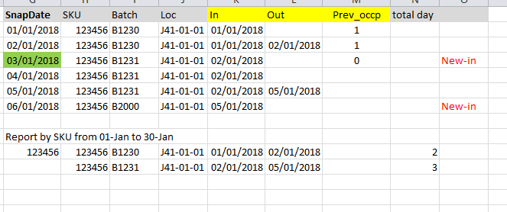

## WMS

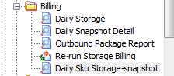

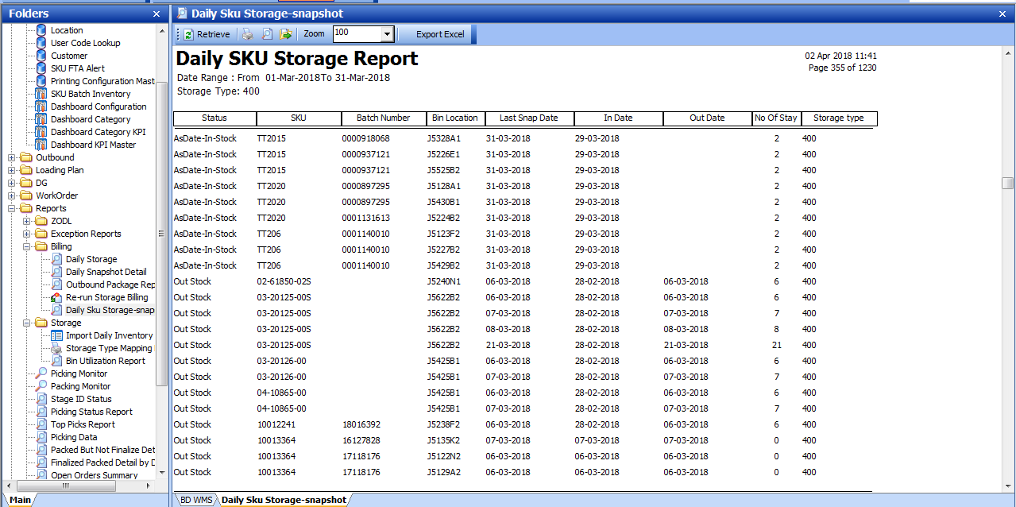

Report Retrieve:

Range of Snapshot Date

Storage Type

Status:

AsDate-In-Stock = as of the last snap date, the stock still in-stock

Out Stock = stock (SKU/Batch) already out from the bin location.

**[Updated 2018.04.11]**

Report:

Parameter: Date range -> include IN_Date within the range and outdate - within the range.

no_of_stay = starting from the report from_date to out-date

Out-date => to display the status as of current report date range.

